
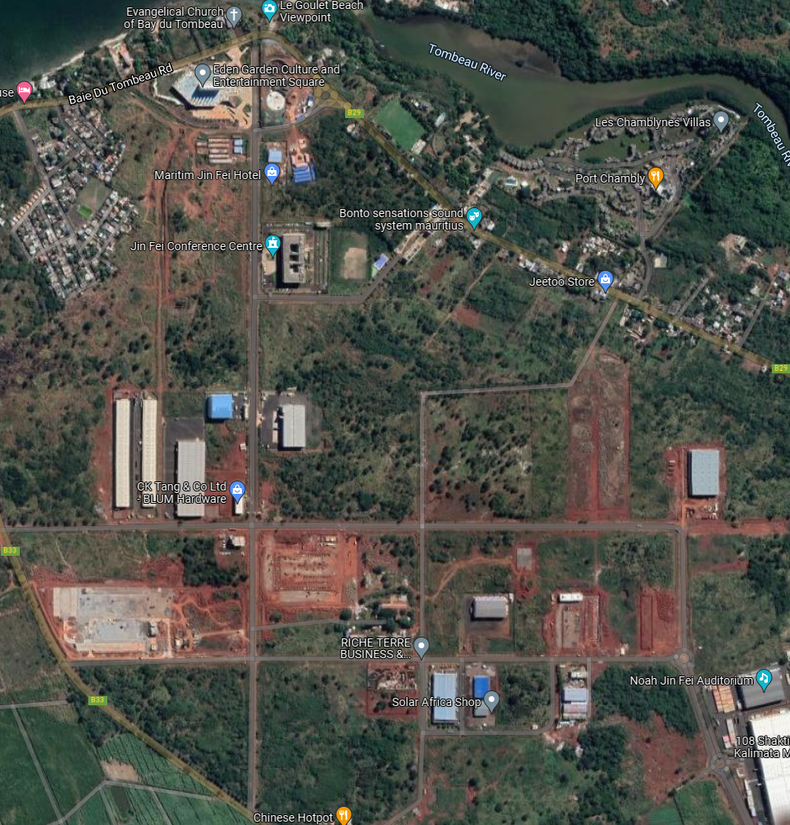
O
TO BAIE DU TOMBEAU
TP
A- Laps scorer - 1
Control-2 @ TP
Pointer – 1 @TP

la

Drinking and sponging station
Pointers- 2@C AND O
Pointer-1@ D
Pointers- 2 @ D
Pointer- 1 @ G
Pointer- 1 @ F
B
START /FINISH @PNL
X
F
HG
G
E
D
C
Pointers- 1 @B and A
Drinking and sponging station
Pointer- 1 @E
ROAD RACE – JIN FEI
15 MARS 2026
COURSE PLAN
Loop: A + B + C + D + B +C+ E + TP + F + G + H + A = 6.9 KM
S/N | Start Time | Run Type | Itinerary | Distance
1 | 07 H 00 | ROAD RACE | Start X+ 3 Loops + A+ O + X | 21.1 kms
2 | 08 H 30 | ROAD RACE | Start X+ A+B+C+E+TP+F+G+H+A+ O + X | 5 kms
3 | 09 H 00 | FUN RUN (Open) | Start X + A + H + G+ O + X | 2.5 kms

