******MAURITIUS ATHLETICS ASSOCIATION**

**VITAL CROSS COUNTRY LEAGUE 2025**

**2nd Leg – M.F.A TRIANON**

**Sunday 31st  August 2025**

START

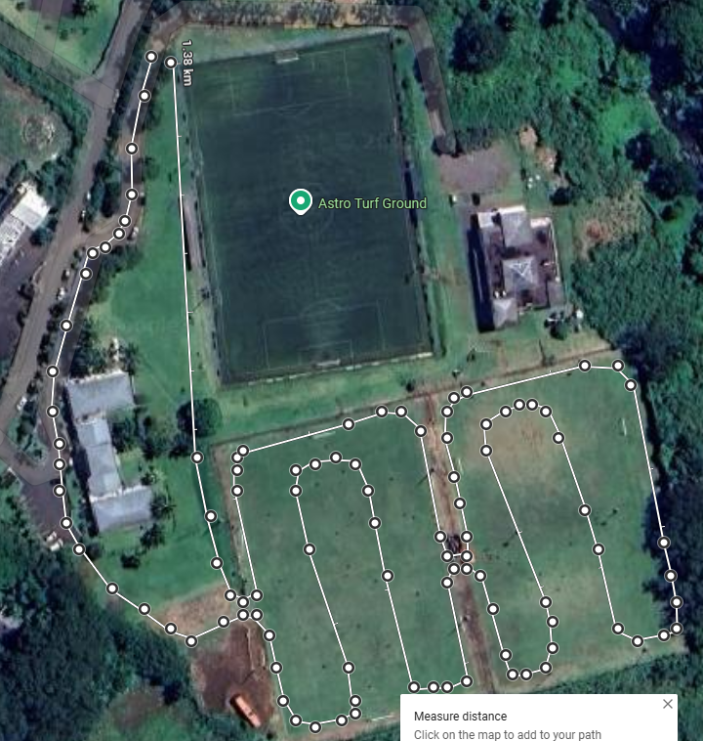

D

E

F

C

B

G

A

X

FINISH

O

MFA COMPLEX

**Circuit (1) – O – A – B – C – D – E – F - B - G - 1.4 KM**

**Circuit (2) -** **O - A - B – C – D - F - B - G - 1.1 KM**

**Circuit (3) - O – A - B- C- D - B – G – 800 Mts**

|  |  |  |  |  |
| --- | --- | --- | --- | --- |
| **1** | **09:00hrs.** | **U10 (B)- (G)** | **Dep O + 1* Circuit (3) - X** | **0.8 Km** |
| **2** | **09:15 hrs.** | **U12 (B) - (G)** | **Dep O + 1* Circuit ( 2) - X** | **1.1 Kms** |
| **3** | **09.30 hrs.** | **U14 (G)** | **Dep O + 1* Circuit (1) - X** | **1.5 Kms** |
| **4** | **09.45 hrs.** | **U14 (B) / U16 (G)** | ***Dep O + 1 Circuit ( 2 ) + 1 * CIRCUIT (1) - X*** | **2 .5 Kms** |
| **5** | **09.55** | **FUN RUN** | **Dep O - 1 Circuit (2 ) - X** | **1.1 Kms** |
| **6** | **10:05 hrs.** | **SEN (M)** | **Dep D – E - F – B – G + 5 *Circuit (1) - X** | **8 Kms** |
| **7** | **10:35 hrs.** | **U16 (B) /U18 (W) & MASTERS(W)** | **Dep B – C - D – E- F – B – G + 2 *Circuit (1 ) - X** | **4 Kms** |
| **8** | **11:00 hrs.** | **U18 (M) - U20 (W) / SEN (W)** | **Dep O + 1 Circuit (3) + 3* Circuit (1) - X** | **5 Kms** |
| **9** | **11.20 hrs.** | **U20 (M) / MAS (M)** | **Dep O + 1 Circuit (3) + 3* Circuit (1) - X** | **5 Kms** |